LAB Logbook

Lab 1
Code:
vector = np.arange(1,99)
vector = vector.reshape(1,vector.size)
print(vector)
newVector = vector
print(newVector)
print(newVector.shape)
Result:
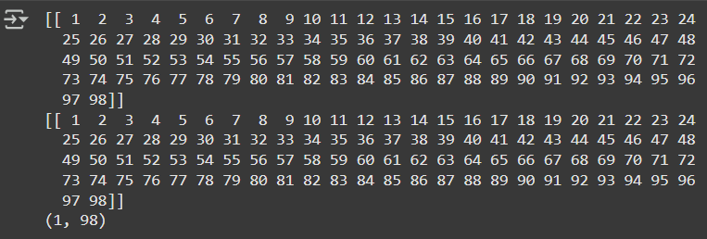

Lab 2
Code:
def subtractHours(x):
return x-9
newData = pd.read_csv('adult_data_mini.csv', header=0)
groupByRelationships = newData.groupby(['relationship', 'hours-per-week'])
groupByRelationshipsF = groupByRelationships.size().unstack()
groupByRelationshipsF

newData['hours-per-week'] = newData['hours-per-week'].apply(subtractHours)
groupByRelationships = newData.groupby(['relationship', 'hours-per-week'])
groupByRelationshipsF2 = groupByRelationships.size().unstack()
groupByRelationshipsF2
Result:
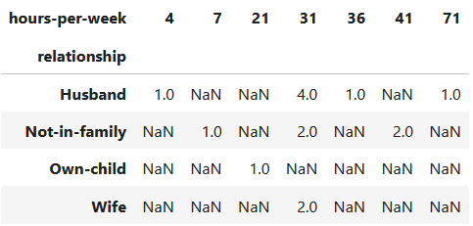

Lab 3
Code:
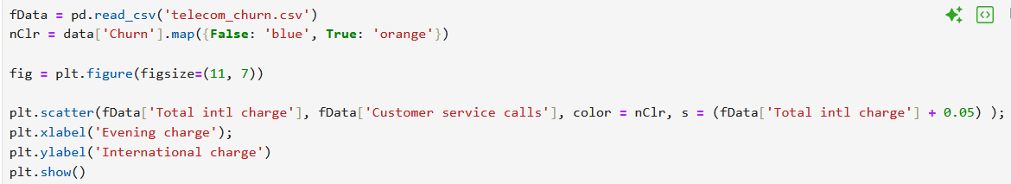
Result:
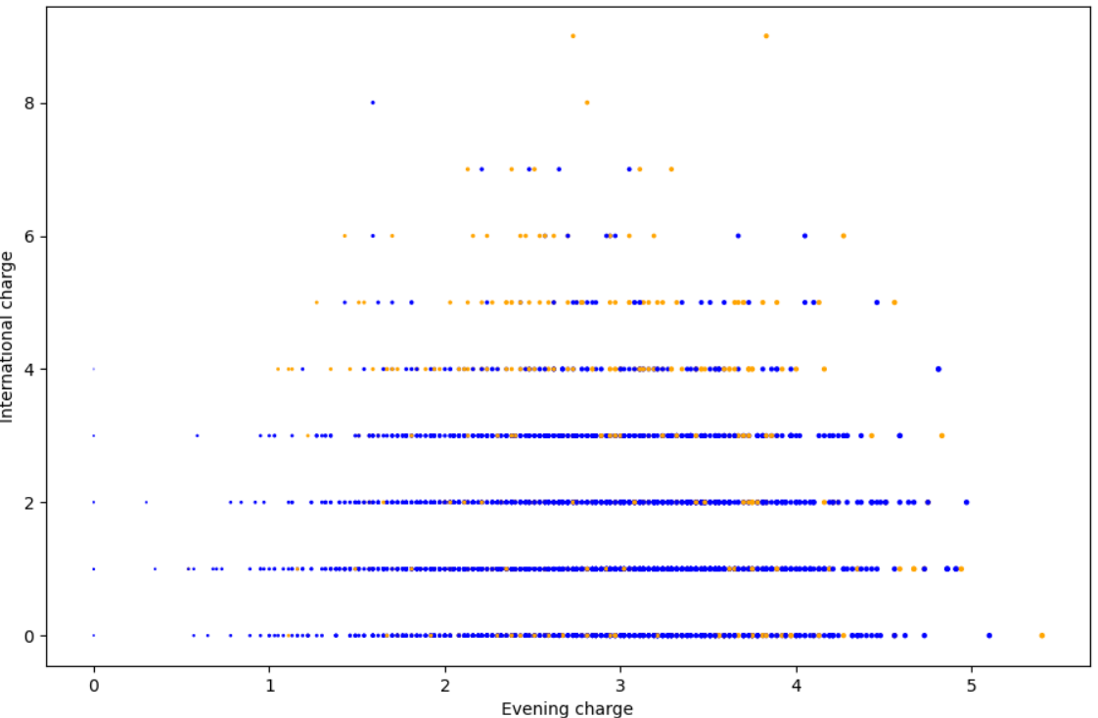

Lab 4
Architecture:
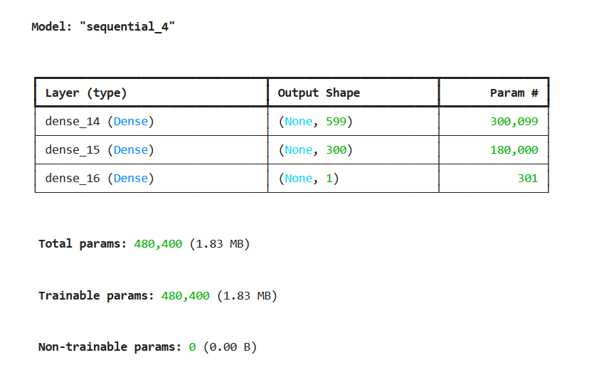
Training Summary:
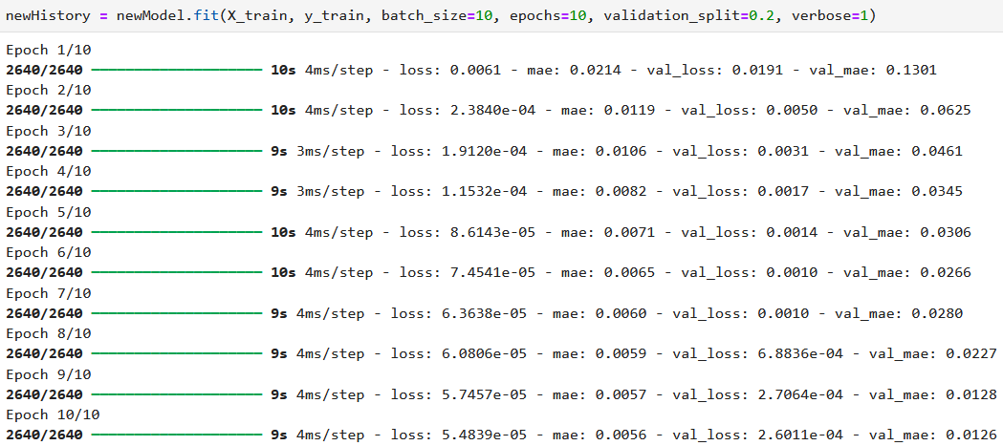
MAE Graph:
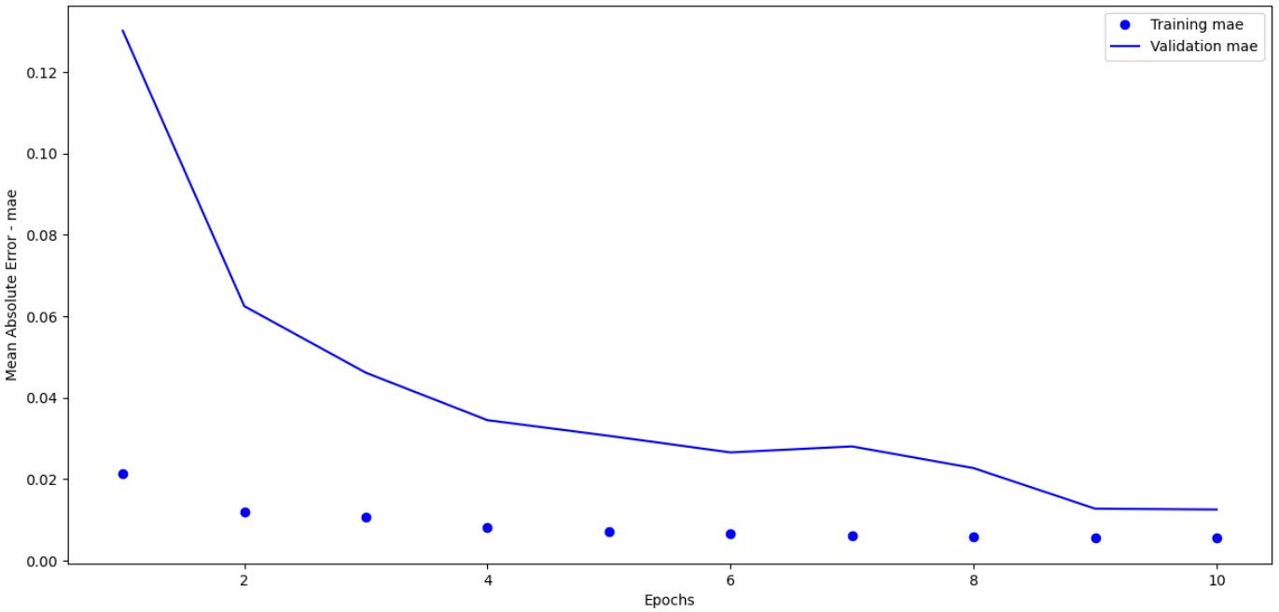
Lab 5
Model Summary:
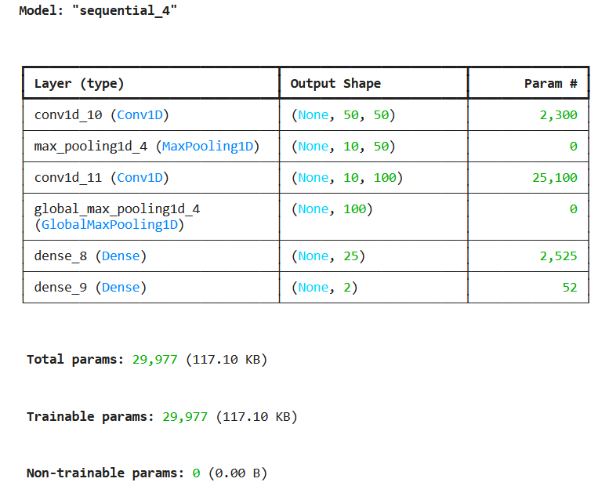
Model Training:
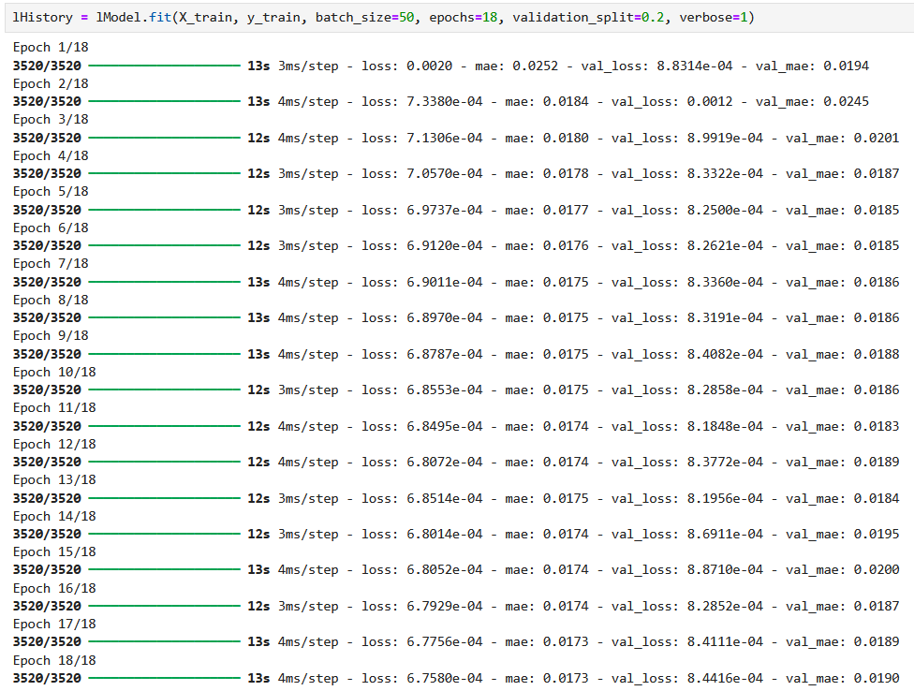
MAE Comparison:
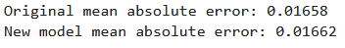
Lab 6

Lab 7
Model Summary:
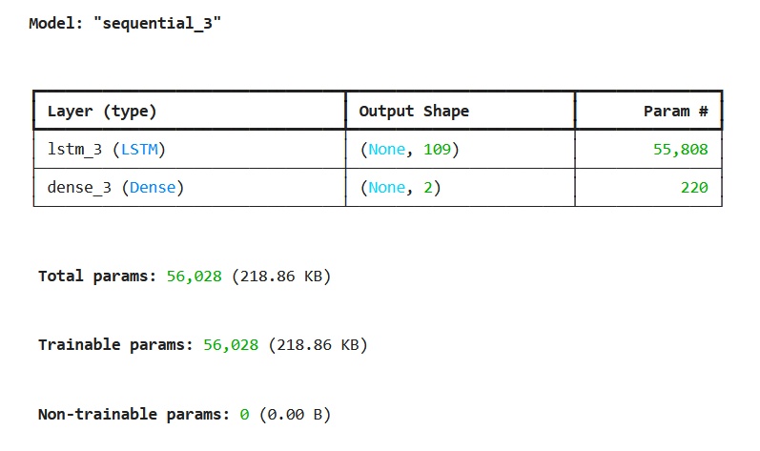
Model Training:
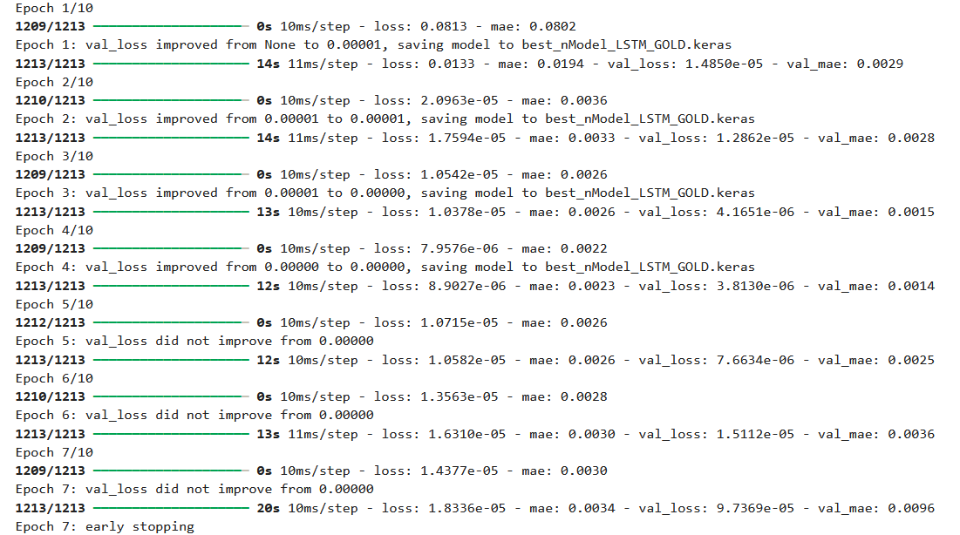
MSE and MAE:
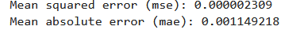
MAE Graph:
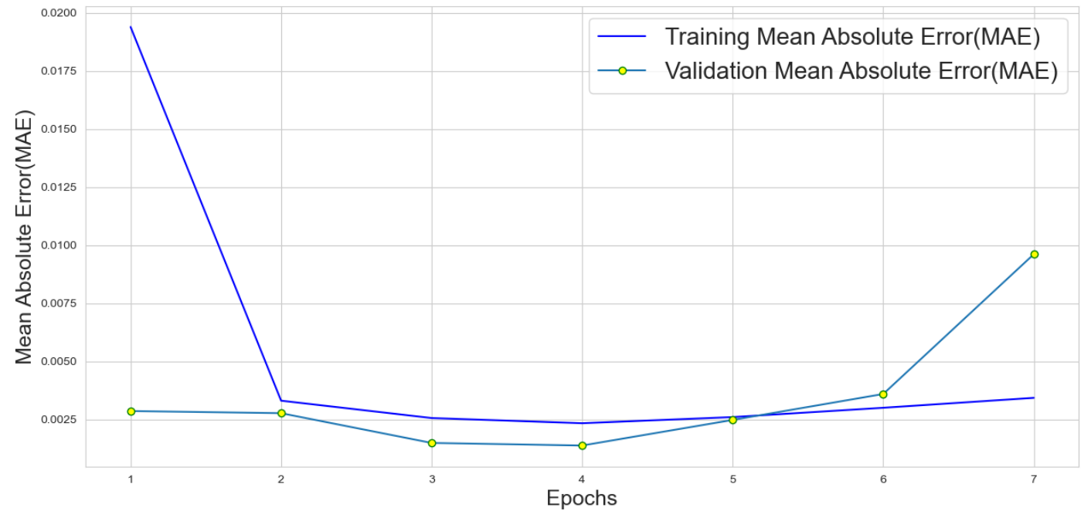

Lab 8
MAE Graph:
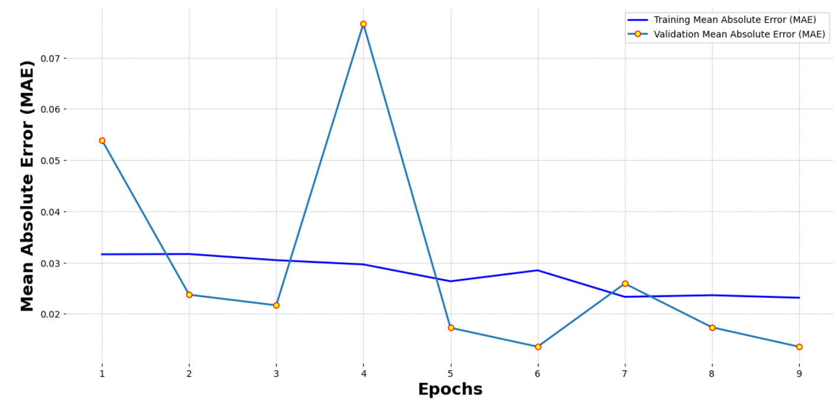
Lab 9

Lab 10
EarlyStopping and ModelCheckpoint:
Model.Fit() Result:
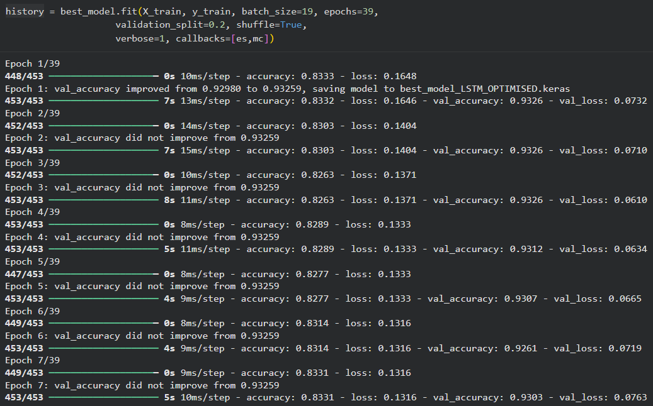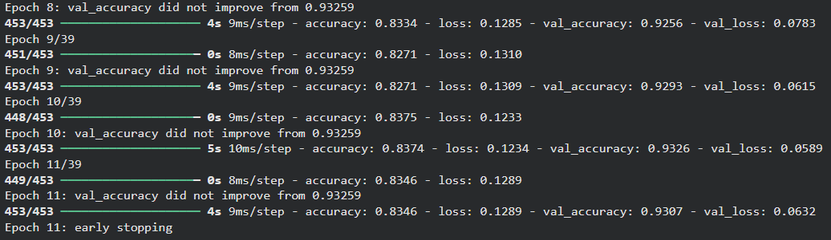
Accuracy:
Accuracy Detailed Graph:
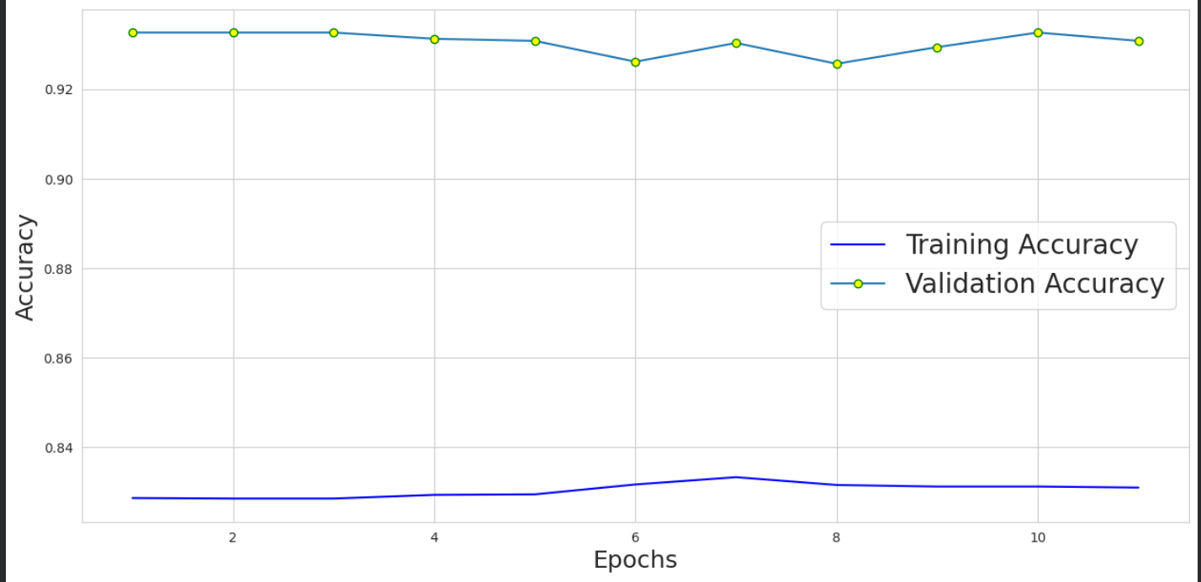
Lab 11
LSTM Addition:
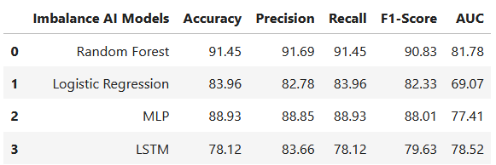
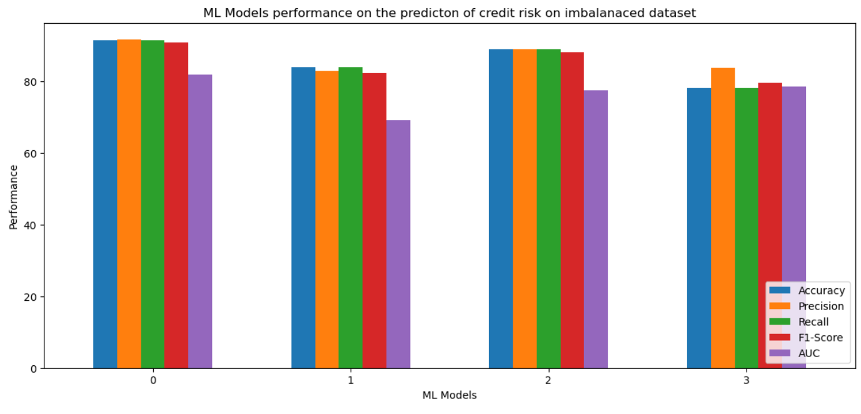
Lab 12

